**Online access to general practice**

**LMC view, This is Contractual ( but we do have significant concerns about safety) see below**

25-26 contract states from 1 October 2025 practices to allow patients to submit routine, non-urgent appointment requests, medication queries and admin requests via online consultation tools during core hours.

This was agreed by the BMA subject to safeguards being put in place to prevent urgent messages being sent through.

This has then been updated in 2025 GMS [regulations](https://i.emlfiles4.com/cmpdoc/2/5/8/0/5/3/files/12949_1.-focus-on-1-oct-25-changes-to-regs-re-patient-contact-with-the-practice-1.pdf) to require all 3 methods of contact to be available during core hours for patients (face to face/telephone and online) with no mention of safeguards or any difference between urgent and routine contacts. A suitable response must be provided on the same working day.

Once your practice has reached safe capacity then consider reporting another PCCAD survey and email syicb-rotherham.primarycare@nhs,net (mark as high importance) to raise safety concerns.

BMA advice to practices about [managing patient care safely](https://i.emlfiles4.com/cmpdoc/2/5/8/0/5/3/files/12952_2.-focus-on...-managing-patient-care-safely-post-1st-october-2025.pdf) from October (September 2025)

On 18th September the GPC voted to [enter dispute](https://www.bma.org.uk/news-and-opinion/gps-in-england-vote-to-re-enter-dispute-with-government) with the government from 1st October due to concerns about unlimited online access becoming a critical patient safety issue.

Katie Brammall-Stainer chair of the GPC short [video](https://www.youtube.com/watch?v=k5mQpuL7PFY)

**GP Connect**

**LMC view, This is contractual to switch on (but we have significant concerns ).**

**Contractual from 1st October.**

There are two parts to this:

***Read -*** *allows read only access to GP records for direct care only by other NHS commissioned providers and private providers with explicit consent from the patient.*

***Update -*** *allows Community Pharmacy to send consultation summaries into the GP practice workflow (GP Connect Update Record).*

Practices need to decide if they wish to get a task to action for GP update record entries ( recommended) or file automatically ( not recommended) . Once the information is saved it **becomes part of the GP record and practice responsibility/visible in the NHS app.**

BMA and RCGP Joint IT Committee have significant concerns that current implementation is not fit for purpose.

BMA FAQs [here](https://i.emlfiles4.com/cmpdoc/2/5/8/0/5/3/files/11645_gp-connect.pdf?utm_campaign=437297_01052025%20NEWSLETTER%20GPs%20England%20M&utm_medium=email&utm_source=The%20British%20Medical%20Association%20%28Comms%20Engagment%29&dm_i=7IPW,9DF5,19CWTG,16XWL,1)

Joint GP IT Committee position [statement](https://cdn.intelligencebank.com/eu/share/qMbw14/NZMLN/3zL4b/original/Joint+GP+IT+Committee+position+statement+on+GP+Connect+150925) 15th September

Legal advice is currently being sought about the implementation of GP Connect. While we cannot advise that you breach your contact by not switching on by the 1st October we suggest holding off while the BMA raises safety concerns with NHS England and we will keep you updated.

**OpenSAFELY**

**LMC view – OK to switch on.**

**Actions needed:**

* **Complete a DPIA**
* **Update privacy notice and practice record of processing activities (RoPA)**
* **Switch on in S1/EMIS**

Practices are legally required to activate access to pseudonymised GP records using the OpenSAFELY research platform by September 2025

Essentially researchers write research code and the open safely platform extracts this data from NHS digital to answer the research questions; researchers only get the specific information requested/do not have access to records. So far, it's been used for only COVID related research but that's being expanded.

BMA is supportive; *‘the approach taken by OpenSAFELY, a pandemic-driven technology innovation, has the ongoing support of the BMA as, from the outset, it has made use of GP coded data in a way that promotes security and transparency, as well as pioneering open ways of working. We think it would be a great loss to the NHS if this platform were not able to continue as we move onwards from the pandemic.’*

Patients can opt out via type 1 form

The RCGP has some [helpful information](https://r1.dotdigital-pages.com/p/49LX-12T5/all-gp-practices-using-emis-web-optum-or-systmon-e-tpp-are-legally-required-to-activate-access-to-pseudonymised-gp-rec-ords-using-the-open-safely-research-platform-by-september-2025)

[Instructions to turn on](https://r1.dotdigital-pages.com/p/49LX-12T5/all-gp-practices-using-emis-web-optum-or-systmon-e-tpp-are-legally-required-to-activate-access-to-pseudonymised-gp-rec-ords-using-the-open-safely-research-platform-by-september-2025)

Simple [explanation video](https://www.opensafely.org/about/)

**InSYghts**

**LMC view - Data shared is anonymised and there is oversight by GPs of what the data is being used for, ok to sign up**

ICB data analysis to get a better understanding of primary care. Most of the data available currently to the ICB at scale is skewed to secondary care.

Data is pseudonymised before entering ICB system.

Requests to access the data are brought to the primary care data advisory group for stewardship and oversight, membership of this includes GPs across SY.

Growth accelerator program sign up linked to this so that outcomes can be analysed.

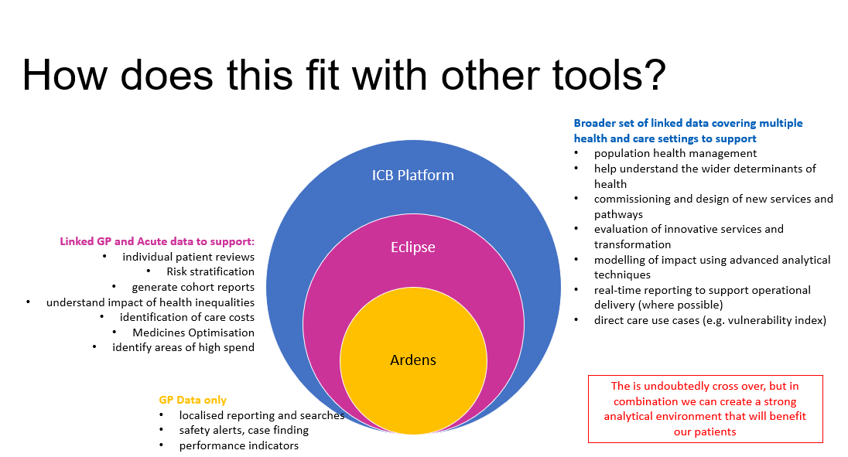

**Yorkshire and Humber Care Record (YHCR)**

**LMC view - Benefits to practice of being able to access hospital data**

Replacing Rotherham health record. Covers Hospitals, YAS, Data coming soon will be from the four SY Local Authorities, Out of Hours Service, RDaSH and SW Yorkshire Partnership. Already rolled out in Sheffield/Barnsley and Doncaster.

Will have more data available to us and be able to view useful information such as outpatient appointment details.

Secondary care staff will be able to view primary care records in same way they can via RHR now.

ICB digital team are contacting practices to onboard.

[Shared Care Record :: South Yorkshire I.C.S.](https://syics.co.uk/digital_innovations/shared-care-record)

**Prospective online access**

**LMC view - If not already, complete a** [**DPIA**](https://www.bma.org.uk/advice-and-support/gp-practices/gp-service-provision/accelerated-access-to-gp-held-patient-records-2023/carrying-out-a-dpia) **so if your practice opted not to open access to all you can justify your decision**

Contractual to offer prospective online access to all remains since October 31st 2023

BMA position statement linked below

[Accelerated Access to Prospective GP Records (BMA Jan25).pdf](https://www.sheffield-lmc.org.uk/website/IGP217/files/Accelerated%20Access%20to%20Prospective%20GP%20Records%20(BMA%20Jan25).pdf)